The Fourth Sunday after Pentecost
July 3, 2022
10:00 a.m.
Image from Hoover Church of Christ

The Episcopal Church of the Ascension

205 W. Cherokee Avenue
Cartersville, Georgia 30120
770-382-2626
www.ascensioncartersville.org

Welcome to The Episcopal Church of the Ascension.
Here “we challenge ourselves and the world to love
like Jesus as we worship joyfully,
serve compassionately and grow spiritually.”

Please remember to silence your cell phone.
The people may make the sign of the cross (optional) when this sign † appears throughout the order of the service.
The Holy Eucharist: Rite Two
The Word of God
The Organ Voluntary

In Green Pastures Harold Darke (1888-1976)

Please stand, as you are able, at the ringing of the bell.

The Hymn in Procession

Hymn 657 Hyfrydol 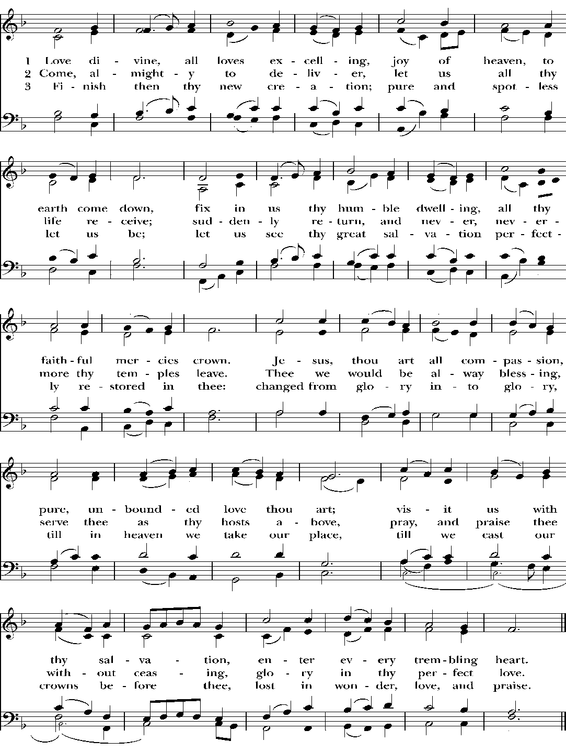
The Opening Acclamation

Celebrant †Blessed be God: Father, Son, and Holy Spirit.
People And blessed be his kingdom, now and for ever. Amen.
The Celebrant may say

Almighty God, to you all hearts are open, all desires known, and from you no secrets are hid: Cleanse the thoughts of our hearts by the inspiration of your Holy Spirit, that we may perfectly love you, and worthily magnify your holy Name; through Christ our Lord. Amen.

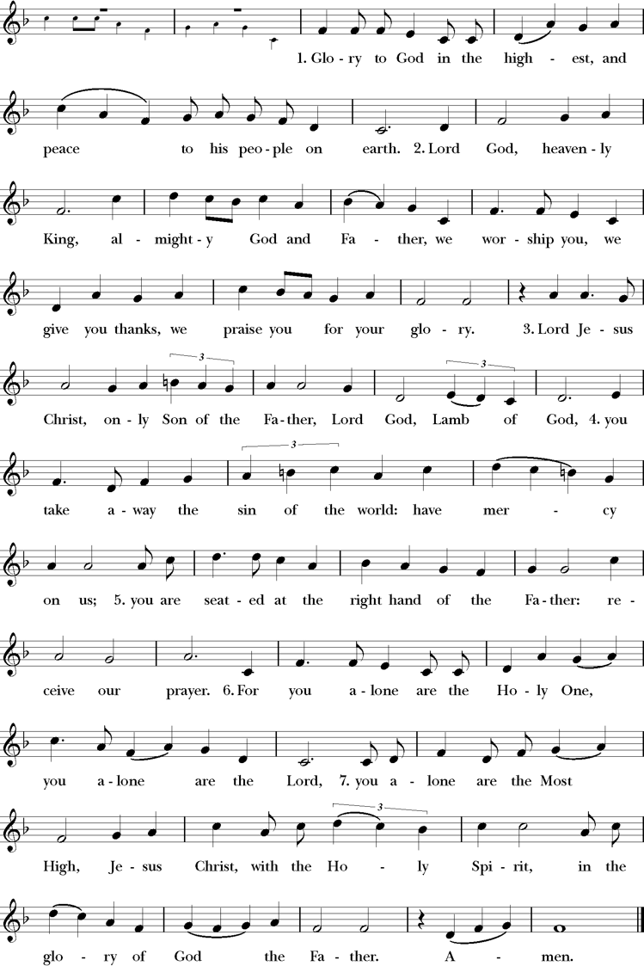
Celebrant and People S 280
Setting: Robert Powell (b.1932)

The Collect of the Day
Celebrant The Lord be with you.
People And also with you.
Celebrant Let us pray.

O God, you have taught us to keep all your commandments by loving you and our neighbor: Grant us the grace of your Holy Spirit, that we may be devoted to you with our whole heart, and united to one another with pure affection; through Jesus Christ our Lord, who lives and reigns with you and the Holy Spirit, one God, for ever and ever. Amen.

The people sit.

The First Lesson Isaiah 66:10-14
Thus says the Lord:
"Rejoice with Jerusalem, and be glad for her,
all you who love her;
rejoice with her in joy,
all you who mourn over her--
that you may nurse and be satisfied
from her consoling breast;
that you may drink deeply with delight
from her glorious bosom.
For thus says the Lord:
I will extend prosperity to her like a river,
and the wealth of the nations like an overflowing stream;
and you shall nurse and be carried on her arm,
and dandled on her knees.
As a mother comforts her child,
so I will comfort you;
you shall be comforted in Jerusalem.
You shall see, and your heart shall rejoice;
your bodies shall flourish like the grass;
and it shall be known that the hand of the Lord is with his servants,
and his indignation is against his enemies."

Lector The Word of the Lord.
People Thanks be to God.

The Response

Psalm 66:1-8 Chanted by the congregation and choir
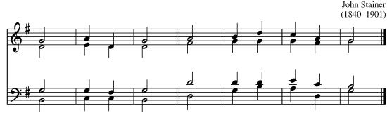
Jubilate Deo

1 Be joyful in God, | all you | lands; *
sing the glory of his Name;
sing the | glory | of his | praise.

2 Say to God, "How awesome | are your | deeds! *
because of your great strength
your | ene- • mies | cringe be- | fore you.

3 All the earth bows | down be- | fore you, *
sings to you, | sïngs | out your | Name."

4 Come now and see the | works of | God, *
how wonderful he is in his | doing | toward all | people.

5 He turned the sea into dry land,
so that they went through the | water • on | foot, *
and there | we re- | joiced in | him.

6 In his might he rules for ever;
his eyes keep watch | over • the | nations; *
let no rebel | rïse | up a- | gainst him.

7 Bless our | God, you | peoples; *
make the voice of his | präise | to be | heard;

8 Who holds our | souls in | life, *
and will not a- | llow our | feet to | slip.

The Second Lesson Galatians 6:7-16

Do not be deceived; God is not mocked, for you reap whatever you sow. If you sow to your own flesh, you will reap corruption from the flesh; but if you sow to the Spirit, you will reap eternal life from the Spirit. So let us not grow weary in doing what is right, for we will reap at harvest-time, if we do not give up. So then, whenever we have an opportunity, let us work for the good of all, and especially for those of the family of faith.
See what large letters I make when I am writing in my own hand! It is those who want to make a good showing in the flesh that try to compel you to be circumcised-- only that they may not be persecuted for the cross of Christ. Even the circumcised do not themselves obey the law, but they want you to be circumcised so that they may boast about your flesh. May I never boast of anything except the cross of our Lord Jesus Christ, by which the world has been crucified to me, and I to the world. For neither circumcision nor uncircumcision is anything; but a new creation is everything! As for those who will follow this rule-- peace be upon them, and mercy, and upon the Israel of God.

Lector The Word of the Lord.
People Thanks be to God.
The Sequence

Hymn 474 Rockingham

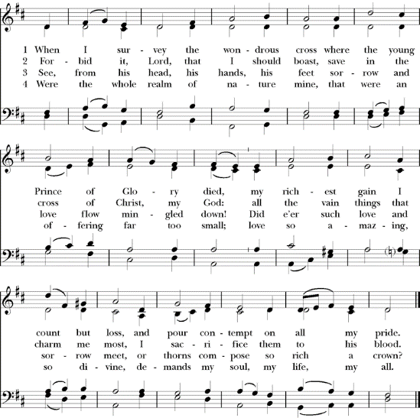

The Gospel Luke 10:1-11, 16-20

Celebrant The Holy Gospel of our Lord Jesus Christ according to Luke.
People Glory to you, Lord Christ.

The Lord appointed seventy others and sent them on ahead of him in pairs to every town and place where he himself intended to go. He said to them, "The harvest is plentiful, but the laborers are few; therefore ask the Lord of the harvest to send out laborers into his harvest. Go on your way. See, I am sending you out like lambs into the midst of wolves. Carry no purse, no bag, no sandals; and greet no one on the road. Whatever house you enter, first say, `Peace to this house!' And if anyone is there who shares in peace, your peace will rest on that person; but if not, it will return to you. Remain in the same house, eating and drinking whatever they provide, for the laborer deserves to be paid. Do not move about from house to house. Whenever you enter a town and its people welcome you, eat what is set before you; cure the sick who are there, and say to them, `The kingdom of God has come near to you.' But whenever you enter a town and they do not welcome you, go out into its streets and say, `Even the dust of your town that clings to our feet, we wipe off in protest against you. Yet know this: the kingdom of God has come near.'

"Whoever listens to you listens to me, and whoever rejects you rejects me, and whoever rejects me rejects the one who sent me."

The seventy returned with joy, saying, "Lord, in your name even the demons submit to us!" He said to them, "I watched Satan fall from heaven like a flash of lightning. See, I have given you authority to tread on snakes and scorpions, and over all the power of the enemy; and nothing will hurt you. Nevertheless, do not rejoice at this, that the spirits submit to you, but rejoice that your names are written in heaven."

Celebrant The Gospel of the Lord.
People Praise to you, Lord Christ.

The Homily The Rev. Spenser Simrill

The Nicene Creed

Celebrant and People

We believe in one God, the Father, the Almighty, maker of heaven and earth, of all that is, seen and unseen.

We believe in one Lord, Jesus Christ, the only Son of God, eternally begotten of the Father, God from God, Light from Light, true God from true God, begotten, not made, of one Being with the Father. Through him all things were made. For us and for our salvation he came down from heaven: by the power of the Holy Spirit he became incarnate from the Virgin Mary, and was made man. For our sake he was crucified under Pontius Pilate; he suffered death and was buried. On the third day he rose again in accordance with the Scriptures; he ascended into heaven and is seated at the right hand of the Father. He will come again in glory to judge the living and the dead, and his kingdom will have no end.

We believe in the Holy Spirit, the Lord, the giver of life, who proceeds from the Father and the Son. With the Father and the Son he is worshiped and glorified. He has spoken through the Prophets. We believe in one holy catholic and apostolic Church. We acknowledge one baptism for the forgiveness of sins. †We look for the resurrection of the dead, and the life of the world to come. Amen.

The Prayers of the People Form VI, BCP

The Leader and People pray responsively

In peace, we pray to you, Lord God.
Silence

For all people in their daily life and work;
For our families, friends, and neighbors, and for those who
are alone.

For this community, the nation, and the world;
For all who work for justice, freedom, and peace.

Eternal God, in whose perfect kingdom no sword is drawn but the sword of righteousness, no strength known but the strength of love: So mightily spread abroad your Spirit, that all peoples may be gathered under the banner of the Prince of Peace, as children of one Father; to whom be dominion and glory, now and forever.

For the just and proper use of your creation;
For the victims of hunger, fear, injustice, and oppression.

For all who are in danger, sorrow, or any kind of trouble;
For those who minister to the sick, the friendless, and the
needy.

For the peace and unity of the Church of God;
For all who proclaim the Gospel, and all who seek the Truth.

For Michael our Presiding Bishop, and Rob our Bishop; and for all bishops and other ministers;
For all who serve God in his Church.

For the special needs and concerns of this congregation.

Silence

The People may add their own petitions

We pray for the Episcopal Church of the Ascension.

Look graciously on your Church, and so guide the minds of those who shall choose a rector for this parish, that we may receive a faithful pastor, who will care for your people and equip us for our ministries.

We pray for all veterans and their families and for those who are currently serving our country in the Armed Forces, especially Stovall Knight, Chandler Celluzi, Taylor Tekesky, Kyle Hubert, and Steven Velencia.

We pray for those among us in need of healing, comfort, support, and compassion.

We pray for those who have asked for our prayers by name, especially Bill Dial, Bob & Claudia White, Nancy Mines, Elizabeth Womack, Bobby Joe Womack, Lamar Tilley, Natalie Barrington, Randolph James, Dan Bennett, The Rev. Louis Tonsmeire, Sam Hood, Drew Tonsmeire, Lynette Pasek, Janet Whitner, Sandy Thornton, and John Schock.

We pray for those who have long-term health problems or are homebound, especially Bonita Harrelson, Sandy Rutters, Glendy Biggs, Hope Cunningham, Sarah McLeod, Houston Suggs, Kimberly Gottardi, John Youd, Steve Novak, George Chesnut, Sally Bonton, Patsy Bennett, and Leigh Selby Savage.

Silence

Hear us Lord;
For your mercy is great.

We thank you, Lord, for all the blessings of this life.

Silence

The People may add their own thanksgivings

We celebrate with those who have a birthday this week, especially Joseph Pruitt-Hall.
We celebrate with those who have a wedding anniversary this week.

Silence

We will exalt you, O God our King;
And praise your Name for ever and ever.

We pray for all who have died, especially Maxine Carlisle, that they may have a place in your eternal kingdom.

Silence

The People may add their own petitions

Lord, let your loving-kindness be upon them;
Who put their trust in you.

We pray to you also for the forgiveness of our sins.

Silence may be kept.

Leader and People

Have mercy upon us, most merciful Father;
in your compassion forgive us our sins,
known and unknown,
things done and left undone; and so uphold us by your Spirit
that we may live and serve you in newness of life,
to the honor and glory of your Name;
through Jesus Christ our Lord. Amen.

The Celebrant concludes with an absolution.

The Peace

Celebrant The peace of the Lord be always with you.
People And also with you.

Parish Notices

The Offertory Anthem

The Presentation

Hymn 579 Melita
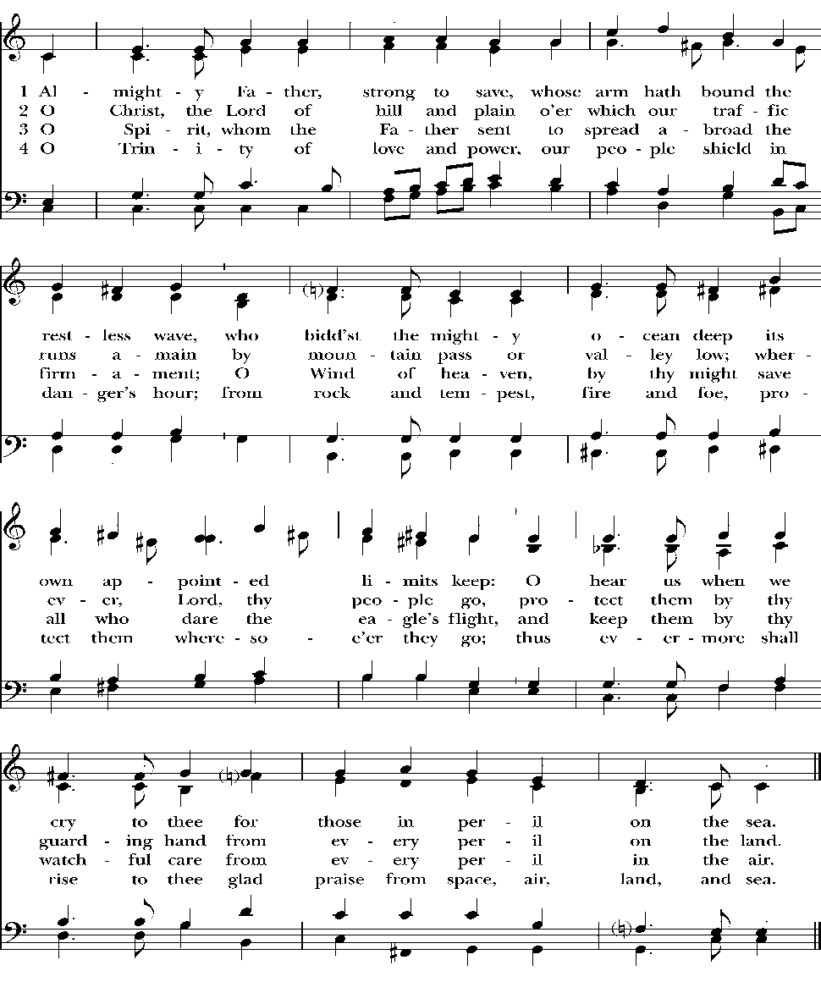
The Holy Communion
The Great Thanksgiving

Celebrant The Lord be with you.
People And also with you.
Celebrant Lift up your hearts.
People We lift them to the Lord.
Celebrant Let us give thanks to the Lord our God.
People It is right to give him thanks and praise.

The Celebrant proceeds

It is right, and a good and joyful thing, always and everywhere to give thanks to you, Father Almighty, Creator of heaven and earth.

Here a Proper Preface is sung or said on all Sundays, and on other occasions as appointed.

Therefore, we praise you, joining our voices with Angels and Archangels and with all the company of heaven, who for ever sing this hymn to proclaim the glory of your Name:

Celebrant and People WLP 858

Setting: American Folk Melody; arr. Marcia Pruner; harm. Annabel Morris Buchanan (1889-1983)
© Church Pension Fund

The Celebrant continues

Holy and gracious Father: In your infinite love you made us for yourself; and, when we had fallen into sin and become subject to evil and death, you, in your mercy, sent Jesus Christ, your only and eternal Son, to share our human nature, to live and die as one of us, to reconcile us to you, the God and Father of all.
He stretched out his arms upon the cross, and offered himself, in obedience to your will, a perfect sacrifice for the whole world.

On the night he was handed over to suffering and death, our Lord Jesus Christ took bread; and when he had given thanks to you, he broke it, and gave it to his disciples, and said, "Take, eat: This is my Body, which is given for you. Do this for the remembrance of me."

After supper he took the cup of wine; and when he had given thanks, he gave it to them, and said, "Drink this, all of you: This is my Blood of the new Covenant, which is shed for you and for many for the forgiveness of sins. Whenever you drink it, do this for the remembrance of me."
Therefore we proclaim the mystery of faith:

Celebrant and People

Christ has died.
Christ is risen.
Christ will come again.

The Celebrant continues

We celebrate the memorial of our redemption, O Father, in this sacrifice of praise and thanksgiving. Recalling his death, resurrection, and ascension, we offer you these gifts.
Sanctify them by your Holy Spirit to be for your people the Body and Blood of your Son, the holy food and drink of new and unending life in him. †Sanctify us also that we may faithfully receive this holy Sacrament, and serve you in unity, constancy, and peace; and at the last day bring us with all your saints into the joy of your eternal kingdom.

All this we ask through your Son Jesus Christ. By him, and with him, and in him, in the unity of the Holy Spirit all honor and glory is yours, Almighty Father, now and for ever. AMEN.

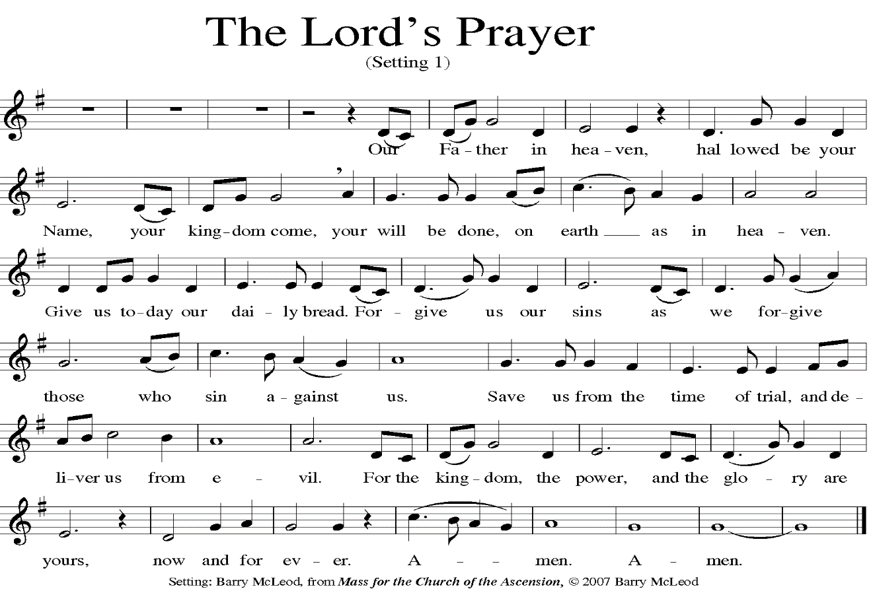
Celebrant As our Savior Christ has taught us, we now pray,

The Breaking of the Bread
The Celebrant breaks the consecrated Bread. A period of silence is kept.

Celebrant Alleluia. Christ our Passover is sacrificed for us;
People Therefore let us keep the feast. Alleluia.

Fraction Anthem WLP 876

Setting: Jack Warren Burnam (b. 1946)

Celebrant The Gifts of God for the People of God.

Hymns during Communion

Hymn 325 Let us Break Bread
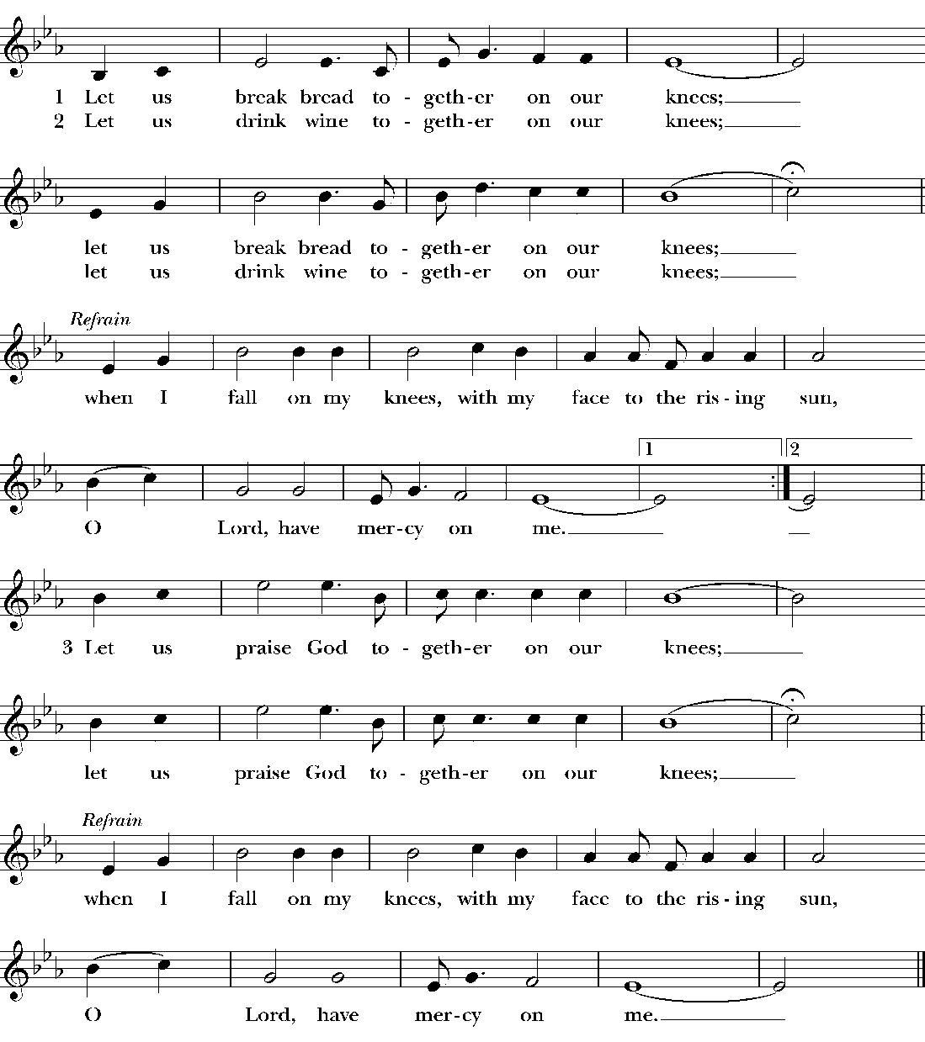

WLP 763 Raquel

As we gather at your Table,
as we listen to your Word,
help us know, O God, your presence;
let our hearts and minds be stirred.
Nourish us with sacred story
till we claim it as our own;
teach us through this holy banquet
how to make Love’s vict’ry known.

Turn our worship into witness
in the sacrament of life;
send us forth to love and serve you,
bringing peace where there is strife.
Give us, Christ, your great compassion
to forgive as you forgave;
may we still behold your image
in the world you died to save.

Gracious Spirit, help us summon
other guests to share that Feast
where triumphant Love will welcome
those who had been last and least.
There no more will envy blind us
nor will pride our peace destroy,
as we join with saints and angels
to repeat the sounding joy.

Setting: Carl P. Daw, Jr. (b. 1944)

If you are worshiping with us virtually, please pray the Prayer for Spiritual Communion.

In union, blessed Jesus, with the faithful gathered at every altar of your Church where your blessed Body and Blood are offered this day, and remembering particularly my own parish and those worshiping at home, I long to offer you praise and thanksgiving, for creation and all the blessings of this life, for the redemption won for us by your life, death, and resurrection, for the means of grace and the hope of glory. And particularly for the blessings given me... I believe that you are truly present in the Holy Sacrament, and since I cannot at this time receive communion, I pray you to come into my heart.
†I unite myself with you and embrace you with all my heart, my soul, and my mind. Let nothing separate me from you; let me serve you in this life until, by your grace, I come to your glorious kingdom and unending peace. Amen.

After Communion, the Celebrant says

Let us pray.

The people stand.

Celebrant and People
Eternal God, heavenly Father, you have graciously accepted us as living members of your Son our Savior Jesus Christ, and you have fed us with spiritual food in the Sacrament of his Body and Blood. Send us now into the world in peace, and grant us strength and courage to love and serve you with gladness and singleness of heart; through Christ our Lord. Amen.
The Blessing

The Hymn in Procession

Hymn 541 Ora Labora
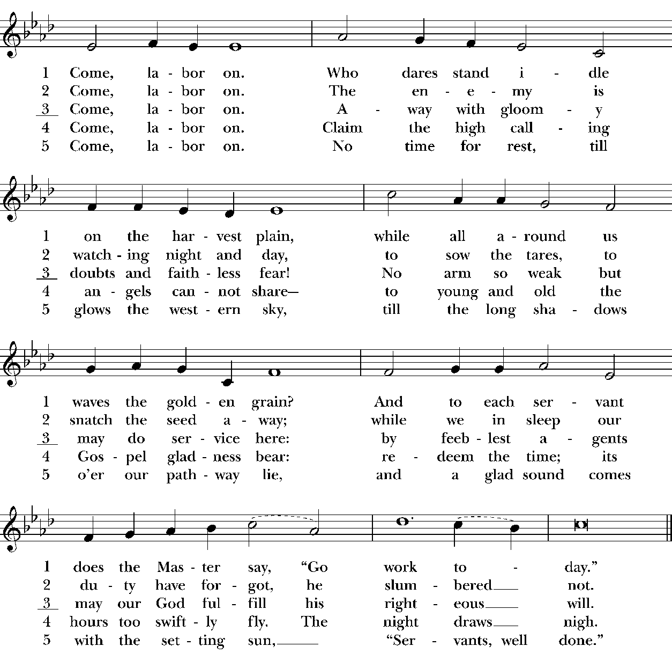

The Dismissal

The Closing Voluntary

Fanfare Kenneth Leighton (1929-1988)

The order of service from the Book of Common Prayer, 1979
according to the use of the Episcopal Church.

The Flowers at the Altar are given
to the Glory of God by
Richard and Sandy Cunningham
in Celebration of the life of
Jackie Magee.

You are called to ministry!
There is a place for you in one of the following ministries. Please contact the ministry leaders listed for more information about where your gifts may fit. If not sure where to start call the church office.

Outreach Liaisons – Linda Hamilton Chairs – Emma Wilhoite
linda@bbaribault.com mmacpaige@gmail.com
John Adams Meghann Humphreys
jcahha@bellsouth.net meghann.humphreys@gmail.com

Building & Grounds Liaison – John Adams Chair – Jamie Hamilton
jcahha@bellsouth.net JHamil2081@bellsouth.net
Christian Formation Liaison – Keith Limardo Chair – Volunteer
klimardo@yahoo.com Needed

Evangelism & Liaison – Brenda Worley Chair – Kelley Dial
Communications brendaworley69@gmail.com kelleydial@gmail.com

Fellowship Liaison – Linda Brunt Chair – Neal Brunt
lbwbrunt@gmail.com brunt@mindspring.com

Finance Liaison – To be announced Chair – Drew Tonsmeire
dtonsmeire@georgiasbdc.org

Technology Liaison – Jeffrey Tindall Chair – Volunteer
jeff@jefftindall.com Needed

Pastoral Care Liaison – Sandi Behrens Chairs – Annette Cook
sbehrens@bellsouth.net annette.cook@comcast.net Kerry Suggs
kerrydan14@gmail.com

Stewardship Liaison – Jimmy Hyde Chair – Corinne Scott
hydejimmy@bellsouth.net acscott333@comcast.net

Liturgy & Worship Liaison – Linda Hamilton Chair – Todd Harper
linda@bbaribault.com tharper@kennesaw.edu
Rick McKee
rmckee54@comcast.net

