The Children’s Christmas Pageant and Holy Eucharist

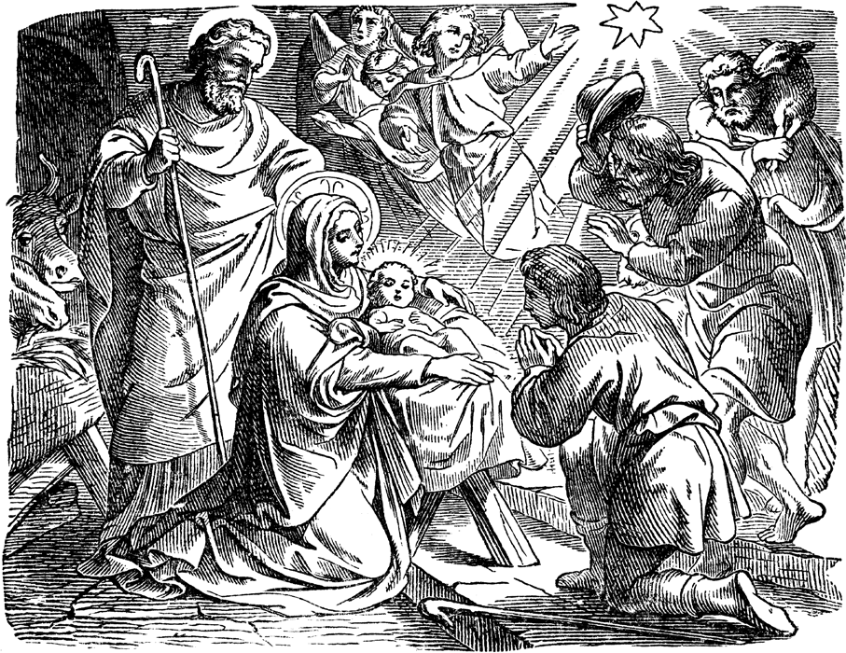

December 24, 2022 at 5:00 p.m.
The Episcopal Church of the Ascension Cartersville, Georgia

December 24, 2022

Dear Members and Friends of Church of the Ascension,

Welcome to this parish church on this most holy evening when we celebrate the birth of our Lord and Savior Jesus Christ. We are delighted you have joined us for the annual Children’s Christmas Pageant and Holy Eucharist. The youngest members of the church are excited to share the Gospel story of Jesus’ birth in both word and song.

Please know that in the Episcopal Church, everyone is welcome at God’s altar. It is God’s table, not ours, and we are glad to share it with you regardless of your background. If you wish to receive communion, please follow the directions listed in the service bulletin. If you wish to receive only a blessing, please cross your arms over your chest as an indication to the Celebrant.

May you know the hope, peace, and joy that this Christmas season offers. If you are visiting, we sincerely hope that you will come back and see us often.

Blessings,

The Rev. Richard H. Winters
Interim Priest

P.S. Remember to silence your cell phones.
“We challenge ourselves and the world to love like Jesus as we worship joyfully, serve compassionately and grow spiritually.”

Opening Voluntary
Please stand, as you are able, at the ringing of the bell.

The Processional Hymn

Hymn 83 O Come All Ye Faithful Adeste fideles

O come, all ye faithful, joyful and triumphant,
O come ye, O come ye to Bethlehem;
come, and behold him, born the King of angels;
(Refrain)
O come, let us adore him, O come, let us adore him,
O come, let us adore him, Christ the Lord.

God from God, Light from Light eternal,
lo! he abhors not the Virgin’s womb;
only begotten Son of the Father;
(Refrain)

Sing, choirs of angels, sing in exultation,
sing, all ye citizens of heaven above;
glory to God, glory in the highest;
(Refrain)

Yea, Lord, we greet thee, born this happy morning;
Jesus, to thee be glory given;
Word of the Father, now in flesh appearing;
(Refrain)

The Salutation and Blessing of the Crèche

The people remain standing.

Celebrant The Word was made flesh and dwelt among us:
People And we beheld his glory.
Celebrant Most merciful and loving God, you have made this day holy by the incarnation of your Son Jesus Christ, and by the child-bearing of the Blessed Virgin Mary: Grant that we your people may enter with joy into the celebration of this day and may also rejoice forever as your adopted sons and daughters; through Jesus Christ our Lord. Amen.

A child places the figure of the Christ Child in the manger of the Crèche.

Hymn 96 Gloria

Angels we have heard on high
singing through the night,
and the mountains in reply
echoing their brave delight.
(Refrain)
Gloria in excelsis Deo.
Gloria in excelsis Deo.

Shepherds, why this jubilee?
Why these songs of happy cheer?
What great brightness did you see?
What glad tidings did you hear?
(Refrain)

Come to Bethlehem and see
him whose birth the angels sing;
come, adore on bended knee
Christ, the Lord, the newborn King.
(Refrain)

See him in a manger laid
whom the angels praise above;
Mary, Joseph, lend your aid,
while we raise our hearts in love.
(Refrain)

The Collect of the Day

The people remain standing.

Celebrant The Lord be with you.
People And also with you.
Celebrant Let us pray.

O God, you have caused this holy night to shine with the brightness of the true Light: Grant that we, who have known the mystery of that Light on earth, may also enjoy him perfectly in heaven; where with you and the Holy Spirit he lives and reigns, one God, in glory everlasting. Amen.

The people sit.

The First Lesson Isaiah 9:2-7

The people who walked in darkness have seen a great light; those who lived in a land of deep darkness – on them light has shined. You have multiplied the nation, you have increased its joy; they rejoice before you as with joy at the harvest, as people exult when dividing plunder. For the yoke of their burden, and the bar across their shoulders, the rod of their oppressor, you have broken as on the day of Midian. For all the boots of the tramping warriors and all the garments rolled in blood shall be burned as fuel for the fire. For a child has been born for us, a son given to us; authority rests upon his shoulders; and he is named Wonderful Counselor, Mighty God, Everlasting Father, Prince of Peace. His authority shall grow continually, and there shall be endless peace for the throne of David and his kingdom. He will establish and uphold it with justice and with righteousness from this time onward and forevermore. The zeal of the LORD of hosts will do this.

Lector The Word of the Lord.
People Thanks be to God.

The Christmas Pageant

The congregation may be seated. The pageant is a dramatization of the story of the birth of Christ foretold in Isaiah and told in the Gospels according to Luke and Matthew. As we hold the proclamation of the Gospel in great reverence, please do not take any photographs or videos during the pageant. We will allow time for that activity at its conclusion. Please refrain from applause for the pageant participants and for the St. Cecilia Choir.

The Christmas Story

Scene 1: This Night is Like No Other…

This night is like no other night. It is a time to dream and sing our way to Bethlehem. We will show you how to go. The little town we seek sits in the hill country some ten miles south of Jerusalem. For thousands of years the houses have gathered there on the hilltop like a family breaking bread. “Bethlehem” means “House of Bread.” In the center of the village is a small inn. On this night it is overflowing with people seeking sleep and a place to eat. Behind the inn is a dark stable. A gray donkey chews his barley and broken straw while a weary cow leans and rests after the day’s plowing in the valley. A sheep nearby is nearly asleep. All is still and quiet in the little town.

(During the hymn the animals come forward)

Hymn: O Little Town of Bethlehem

O little town of Bethlehem ,
how still we see thee lie!
Above thy deep and dreamless sleep
the silent stars go by;
yet in thy dark streets shineth
the everlasting Light;
the hopes and fears of all the years
are met in thee tonight.

Scene 2: Mary and Joseph Come to Bethlehem

(Mary and Joseph come forward.)

As the night gathers, the last two travelers come slowly up the road. Look, there is a young woman about to be a mother. She is walking with her husband. They are Joseph and Mary of Nazareth! They have walked for six days to come to this city where King David was born, so long ago. They have come, like so many others, because the Roman emperor wants to count each one, so he can take their money as a tax. But it is late, and Mary is so weary. Where will they sleep?

Joseph: Are you sure there is no room?
Innkeeper: No, we are overflowing with people.
Mary: But I am so weary. Is there any place we can stay?
Innkeeper: I do have a stable with a single manger, where animals are kept. It is yours if you please.

Hymn: Once in Royal David’s City

Once in royal David’s city
stood a lowly cattle shed,
where a mother laid her baby
in a manger for his bed:
Mary was that mother mild,
Jesus Christ her little child.

Scene 3: Jesus is Born

Stars brighten slowly in the sky. All creation holds its breath. Suddenly, from the stable, comes the cry of a newborn child! Mary gently wraps the baby in a blanket and lays him in the feed box that his father has filled with straw.

(During the hymn baby Jesus is brought forward by the angel Gabriel.)

Hymn: Away in a Manger

Away in a manger, no crib for his bed,
the little Lord Jesus laid down his sweet head.
The stars in the bright sky looked down where he lay,
the little Lord Jesus asleep on the hay.

The cattle are lowing, the baby awakes,
but little Lord Jesus no crying he makes,
I love thee, Lord Jesus! Look down from the sky,
and stay by my side until morning is nigh.

Scene 4: The Angels Sing… Shepherds Come

Outside the city of Bethlehem, shepherds watch their sheep on darkened hills. All at once, the darkness is lost in light, and in the midst of the light is something even brighter: the faces of angels.

(Gabriel, Angels and Shepherds come forward)

The fearful shepherds then hear music in the sky, and a voice says clearly,

Gabriel: Do not be afraid. Listen, I bring you news of great joy, a joy to be shared by all people. Today in the city of David a Savior is born! He is Christ the Lord.

Then more angels appear, a whole heavenly host of them, praising God and singing:

Angels: Glory to God in the highest, and on earth peace, and good will to all people, everywhere.

The Shepherds run with joy across the fields to Bethlehem to the barn behind the inn. There they find the Holy Family and creep forward, overwhelmed with mystery, to find Nativity itself in the center of all that love.

Hymn: Hark! the herald angels sing

Hark! the herald angels sing
glory to the newborn King!
Peace on earth and mercy mild,
God and sinners reconciled!
Joyful, all ye nations, rise,
join the triumph of the skies;
with the angelic host proclaim
Christ is born in Bethlehem!
Hark! the herald angels sing
glory to the newborn King!

Scene 5: Three Wise Kings Follow a Star

Three camels plod up the road to Bethlehem. They have come from the East, far and beyond the Arabian Desert, perhaps from as far as the Caspian Sea. The camels carry three kings, the wise ones, the Magi.

(The star and the three kings come forward.)

They are following the wild star, the destiny they had never seen before, and they are following it, wherever it goes, to find the King its shining shows them.

Hymn: We Three Kings

We three kings of Orient are,
bearing gifts we traverse afar,
field and fountain, moor and mountain,
following yonder star.
O star of wonder, star of night,
star with royal beauty bright;
westward leading, still proceeding,
guide us to thy perfect light!

Scene 6: What Can I Give Him?

The kings’ journey ends with a new kind of king. Their restlessness rests at last.

(The three kings and shepherds bow before the newborn King.)

They fall to their knees and give him the bright gold, sweet-smelling frankincense and bitter myrrh, brought so far with so much love.

So now we all come, following the star, to find God with us. We come, as people have come all through the ages, to bring our own gifts to this Child, God’s gift to us.

Come forward now. Bring your gifts of stars and of yourselves to place around the manger. Show us the way into the Mystery of Christmas as we sing, for this night is holy and filled with overflowing silence.

(During this, children in pews are encouraged to come forward with the stars they received earlier.)

Hymn: What Child Is This

What child is this, who laid to rest,
on Mary’s lap is sleeping?
Whom angels greet with anthems sweet
while shepherds watch are keeping?
(Refrain)
This, this is Christ the King,
whom shepherds guard and angels sing;
haste, haste to bring him laud,
the babe, the son of Mary.

Why lies he in such mean estate
where ox and ass are feeding?
Good Christian, fear: for sinners here
the silent Word is pleading.
(Refrain)

So bring him incense, gold and myrrh,
come, peasant, king, to own him:
the King of kings salvation brings,
let loving hearts enthrone him.
(Refrain)

You may now take pictures of pageant participants. Thank you for your patience!

The Prayers of the People

Please stand or kneel as you are able.
The Leader and People pray responsively.

Intercessor The Word has been made flesh, the light of God’s love has broken through our darkness, the Daystar from on high now shines in our hearts. Filled with the joy of Jesus’ birth, let us pray together in the power of his Spirit, responding, “Lord, hear our prayer.”

Intercessor That the Prince of Peace may guide the leaders of the nations, and all men and women everywhere, into the ways of freedom and truth; let us pray.
People Lord, hear our prayer.

Intercessor For Justin, Archbishop of Canterbury; Michael, our Presiding Bishop; and Robert, our Bishop; that they may guide us in our journey to Bethlehem, uniting the whole Church as we live into our spiritual kinship with one another; let us pray.
People Lord, hear our prayer.

Intercessor For those for whom the darkness has suffocated hope: the lonely, the fearful, the hungry, and those who bear a private grief; that they may see the dawn of God’s love, and revive the eternal hope that never fades away; let us pray.
People Lord, hear our prayer.

Intercessor For our families and friends, and for all our absent sisters and brothers; for those who have died and who now feast at the heavenly banquet of God’s grace; let us pray.
People Lord, hear our prayer.

Intercessor That we who gather to share the Holy Eucharist, and those throughout the world who come to receive this sacrament of Holy Presence, may bear witness to Christ born in our hearts; let us pray.
People Lord, hear our prayer.

Intercessor In the wonder of this night, let us continue to offer our petitions silently or aloud.

(Special intentions of the congregation, the Diocese, and the Anglican Communion may be added here.)

The Celebrant adds a concluding Collect.

The Peace

Celebrant The peace of the Lord be always with you.
People And also with you.

Then the Ministers and People may greet one another in the name of the Lord.

Christmas Greetings

THE HOLY COMMUNION

The Celebrant may begin the Offertory with one of the sentences from the Book of Common Prayer or with some other sentence of Scripture. During the Offertory, a hymn, psalm, or anthem may be sung. Representatives of the congregation bring the people’s offerings of bread and wine, and money or other gifts forward. The people stand while the offerings are presented and placed on the Altar.

The Offertory

The Anthem Dormi, Dormi Italian Carol, arr. by Mary Goetze

Sleep, O sleep my lovely child. King Divine, King Divine. Close your eyes and sweetly slumber. King Divine, King Divine. Close your eyes and sweetly slumber. Fa la la. O my treasure, do not weep. Sweetly sleep, Sweetly sleep. Close your eyes my Son, my dear one. Sweetly sleep, Sweetly sleep. Close your eyes, my Son, my dear one. Fa la la.

The Great Thanksgiving
The people stand

Celebrant The Lord be with you.
People And also with you.
Celebrant Lift up your hearts.
People We lift them to the Lord.
Celebrant Let us give thanks to the Lord our God.
People It is right to give him thanks and praise.

The Celebrant continues

It is right, and a good and joyful thing, always and everywhere to give thanks to you, Father Almighty, Creator of heaven and earth. Because you gave Jesus Christ, your only Son, to be born of us; who, by the mighty power of the Holy Spirit, was made perfect Man of the flesh of the Virgin Mary his mother; so that we might be delivered from the bondage of sin, and receive power to become your children. Therefore we praise you, joining our voices with Angels and Archangels and with all the company of heaven, who forever sing this hymn to proclaim the glory of your Name:

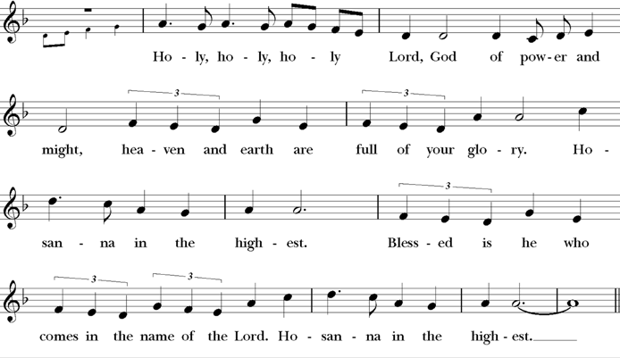
Celebrant and People
The people stand or kneel.

We give thanks to you, O God, for the goodness and love which you have made known to us in creation; in the calling of Israel to be your people; in your Word spoken through the prophets; and above all in the Word made flesh, Jesus, your Son. For in these last days you sent him to be incarnate from the Virgin Mary, to be the Savior and Redeemer of the world. In him, you have delivered us from evil, and made us worthy to stand before you. In him, you have brought us out of error into truth, out of sin into righteousness, out of death into life.

On the night before he died for us, our Lord Jesus Christ took bread; and when he had given thanks to you, he broke it, and gave it to his disciples, and said, “Take, eat: This is my Body, which is given for you. Do this for the remembrance of me.”

After supper he took the cup of wine; and when he had given thanks, he gave it to them, and said, “Drink this, all of you: This is my Blood of the new Covenant, which is shed for you and for many for the forgiveness of sins. Whenever you drink it, do this for the remembrance of me.”

Therefore, according to his command, O Father,

Celebrant and People

We remember his death,
We proclaim his resurrection,
We await his coming in glory;

The Celebrant continues
And we offer our sacrifice of praise and thanksgiving to you, O Lord of all; presenting to you, from your creation, this bread and this wine.

We pray you, gracious God, to send your Holy Spirit upon these gifts that they may be the Sacrament of the Body of Christ and his Blood of the new Covenant.

Unite us to your Son in his sacrifice, that we may be acceptable through him, being sanctified by the Holy Spirit. In the fullness of time, put all things in subjection under your Christ, and bring us to that heavenly country where, with all your saints, we may enter the everlasting heritage of your sons and daughters; through Jesus Christ our Lord, the firstborn of all creation, the head of the Church, and the author of our salvation.

By him, and with him, and in him, in the unity of the Holy Spirit all honor and glory is yours, Almighty Father, now and forever. AMEN.

The Lord’s Prayer

Celebrant And now, as our Savior Christ has taught us, we are bold to say,
People and Celebrant

Our Father, who art in heaven, hallowed be thy Name, thy kingdom come, thy will be done, on earth as it is in heaven. Give us this day our daily bread. And forgive us our trespasses, as we forgive those who trespass against us. And lead us not into temptation, but deliver us from evil. For thine is the kingdom, and the power, and the glory, forever and ever. Amen.

The Breaking of The Bread

The Celebrant breaks the consecrated Bread.
A period of silence is kept.

Celebrant Alleluia. Christ our Passover is sacrificed for us;

People Therefore let us keep the feast. Alleluia.

The Celebrant says the following Invitation to the people

The Gifts of God for the People of God.

Please come to the altar rail and either kneel or stand. Hold out your crossed hands to receive the bread. You may partake of the wine by drinking from the common cup or dipping your bread into the wine. If you do not wish to receive the wine, cross your arms across your chest, and the chalice bearer will pass you by.

If you desire to receive only a blessing, please cross your arms across your chest as a sign to the Celebrant.

During the ministration of Communion, hymns, psalms, or anthems may be sung.

The Music at Communion
Hymn 112 In the bleak midwinter Cranham

In the bleak midwinter, frosty wind made moan,
earth stood hard as iron, water like a stone;
snow had fallen, snow on snow, snow on snow,
in the bleak midwinter, long ago.

Our God, heaven cannot hold him, nor earth sustain;
heaven and earth shall flee away when he comes to reign:
in the bleak midwinter a stable place sufficed
the Lord God incarnate, Jesus Christ.

Angels and archangels may have gathered there,
cherubim and seraphim thronged the air;
but his mother only, in her maiden bliss,
worshiped the beloved with a kiss.

What can I give him, poor as I am?
If I were a shepherd, I would bring a lamb;
if I were a wise man, I would do my part;
yet what I can I give him--give my heart.

The Postcommunion Prayer

Celebrant Let us pray.
People Loving God, you have made us one with your saints in heaven and on earth, and you have joined us together in the Sacrament of Christ’s Body and Blood. Send us forth to share the good news of your love, through Jesus Christ our Lord. Amen.

Hymn 111 Silent Night Stille Nacht

Silent night, holy night,
all is calm, all is bright
round yon virgin mother and child.
Holy infant, so tender and mild,
sleep in heavenly peace.
Sleep in heavenly peace.

Silent night, holy night,
shepherds quake at the sight,
glories stream from heaven afar,
heavenly hosts sing alleluia;
Christ, the Savior, is born!
Christ, the Savior, is born!

Silent night, holy night,
Son of God, love’s pure light
radiant beams from thy holy face,
with the dawn of redeeming grace,
Jesus, Lord, at thy birth.
Jesus, Lord, at thy birth.

The Blessing

May Almighty God, who sent his Son to take our nature upon him, bless you in this holy season, scatter the darkness of sin, and brighten your heart with the light of his holiness. Amen.

May God, who sent his angels to proclaim the glad news of the Savior’s birth, fill you with joy, and make you heralds of the Gospel. Amen.

May God, who in the Word made flesh joined heaven to earth and earth to heaven, give you his peace and favor. Amen.

And the blessing of God Almighty, Father, Son, and Holy Spirit, be upon you and remain with you forever. Amen.

The Processional Hymn
The people turn, facing the cross as it leads the procession.

Hymn 100 Joy to The World Antioch

Joy to the world! the Lord is come:
let earth receive her King;
let every heart prepare him room,
and heaven and nature sing,
and heaven and nature sing,
and heaven, and heaven and nature sing.

Joy to the world! the Savior reigns;
let us our songs employ,
while fields and floods, rocks, hills and plains,
repeat the sounding joy,
repeat the sounding joy,
repeat, repeat the sounding joy.

No more let sins and sorrows grow,
nor thorns infest the ground;
he comes to make his blessings flow
far as the curse is found,
far as the curse is found,
far as, far as the curse is found.

He rules the world with truth and grace,
and makes the nations prove
the glories of his righteousness,
and wonders of his love,
and wonders of his love,
and wonders, wonders of his love.

The Dismissal

The congregation is dismissed to follow the cross into the world, and the people respond:
People Thanks be to God.

Closing Voluntary

All are invited to a reception following the service.
Come join us!

Hymn permission used by Rite Song: a use and reprint license for congregational use.
Order of service from the Book of Common Prayer, 1979 according to the use of
the Episcopal Church.

Thank you to all who donated to adorn the church with Christmas flowers.
In Memory of:
- Loved ones of Jackson & Davis families given by Mike & Jane Davis
- Harriett (Happy) Adams given by John Adams
- My wife, Sandra, given by Bill Davey
- Beau Satterfield Kennedy given by Marty Knight
- Houston Suggs given by Kerry Suggs
- Emily Hatfield & Gerry Hoyt given by Joe & Kathi White
- George Tasker, III and Helen & George Tasker, Jr. given by Mickey Tasker
- Christopher Robert Mines given by Bob & Nancy Mines
- Larry Pritchard given by Connie Evans
- Jack Eastland given by Sis Eastland
- John Youd given by the Youd Family
- Lillian, Norman, & Gerald Deignan given by Marilyn Guthrie
- Cindy Chastain Wade given by Marcia Chastain Humphreys
- Randolph James & Gordon Ganter given by Charles Snider
- All of our departed loved ones given by Bob & Sandy Rutters
In Thanksgiving for:

- Our family given by Richard & Sandy Cunningham
- Our family and friends given by Jimmy & Pam Hyde
- Louis, Jr. and Drew Tonsmeire and their families, given by Louis & Sally Tonsmeire
- For Ascension church and all she has meant to us, and to the people of Ascension. You will remain in our hearts given by Joe & Kathi White
- Tasker children and grandchildren and Bob Dardin given by Mickey Tasker
- Ivey Harris given by Clive Smart
- Grandsons: Hilles, Finn, & Milo given by Gale & Ernie Palmer
- Our family given by Jerry & Lola Thomas
- Our family given by Sam & Beth Hood
- All of our friends and families given by Bob & Sandy Rutters

Merry Christmas
from
The Vestry, Clergy and Staff of
The Episcopal Church of the Ascension

May your Christmas season be filled with all the blessings
of this sacred time:
Faith, hope, joy and peace!

The Episcopal Church of the Ascension
205 W. Cherokee Avenue
Cartersville, Georgia 30120
770-382-2626
www.ascensioncartersville.org

